1-OTP

🔐 What is OTP (One-Time Password)?
# Source: AI Source: Provided by: [Data Path: Persons Table -> ID Column: 1, Name_En Column: Motasem Essam] -> From: [ChatGPT] on [1/18/2026]
OTP stands for One-Time Password — a temporary, automatically generated code used to verify a user’s identity.
It’s typically used in login, signup, payments, or sensitive actions to prevent unauthorized access.

✅ Key Characteristics of OTP:
# Source: AI Source: Provided by: [Data Path: Persons Table -> ID Column: 1, Name_En Column: Motasem Essam] -> From: [ChatGPT] on [1/18/2026]
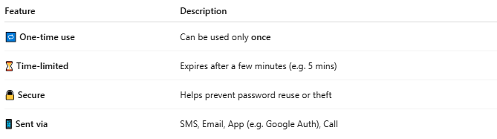

Feature | Description
🔁 One-time use | Can be used only once
⏳ Time-limited | Expires after a few minutes (e.g. 5 mins)
🔒 Secure | Helps prevent password reuse or theft
📱 Sent via | SMS, Email, App (e.g. Google Auth), Call

📦 Common OTP Use Cases:
# Source: AI Source: Provided by: [Data Path: Persons Table -> ID Column: 1, Name_En Column: Motasem Essam] -> From: [ChatGPT] on [1/18/2026]
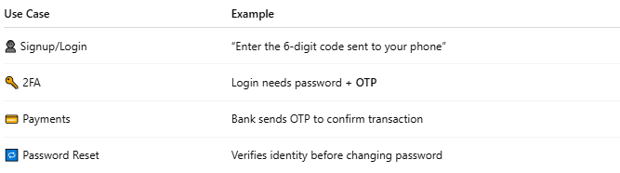

Use Case | Example
👤 Signup/Login | “Enter the 6-digit code sent to your phone”
🔑 2FA | Login needs password + OTP
💳 Payments | Bank sends OTP to confirm transaction
🔁 Password Reset | Verifies identity before changing password

🧪 Example OTP:
# Source: AI Source: Provided by: [Data Path: Persons Table -> ID Column: 1, Name_En Column: Motasem Essam] -> From: [ChatGPT] on [1/18/2026]
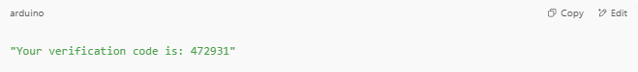
"Your verification code is: 472931"

Or:
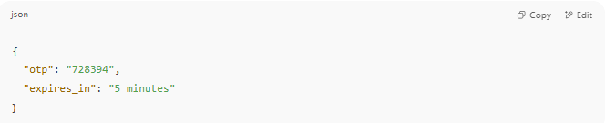
{
"otp": "728394",
"expires_in": "5 minutes"
}

🛠️ How OTP Works (Simple Flow):
# Source: AI Source: Provided by: [Data Path: Persons Table -> ID Column: 1, Name_En Column: Motasem Essam] -> From: [ChatGPT] on [1/18/2026]
- User submits phone/email.
- System generates a random code (e.g., 546891).
- OTP is sent via SMS, email, or app.
- User enters the OTP.
- System verifies it and grants access if valid.

🛡️ Why OTP is Important
# Source: AI Source: Provided by: [Data Path: Persons Table -> ID Column: 1, Name_En Column: Motasem Essam] -> From: [ChatGPT] on [1/18/2026]
- Protects against password theft
- Blocks bots and fake users
- Secures financial transactions
- Adds a second layer of login security (2FA)

2-OTP Verification

✅ What is OTP Verification?
# Source: AI Source: Provided by: [Data Path: Persons Table -> ID Column: 1, Name_En Column: Motasem Essam] -> From: [ChatGPT] on [1/18/2026]
OTP Verification is the process of confirming a user's identity by asking them to enter a One-Time Password (OTP) sent to their email or phone number. It's a security mechanism commonly used in apps, websites, and financial systems.

🔐 How OTP Verification Works
# Source: AI Source: Provided by: [Data Path: Persons Table -> ID Column: 1, Name_En Column: Motasem Essam] -> From: [ChatGPT] on [1/18/2026]
Example Scenario: User Signup
- Users signs up with their phone/email.
- Server generates an OTP (e.g., 763215).
- OTP is sent via:
  - 📱 SMS (Phone Number Verification)
  - 📧 Email (Email Verification)
- User enters the code in the app.
- Server checks if:
  - OTP is correct
  - OTP is not expired
- If valid ➝ User is verified ✅
If invalid/expired ➝ Show error ❌

⏳ Typical OTP Settings
# Source: AI Source: Provided by: [Data Path: Persons Table -> ID Column: 1, Name_En Column: Motasem Essam] -> From: [ChatGPT] on [1/18/2026]
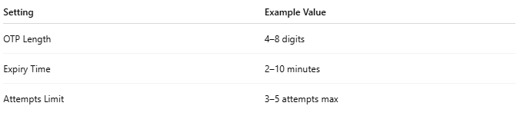
Setting | Example Value
OTP Length | 4–8 digits
Expiry Time | 2–10 minutes
Attempts Limit | 3–5 attempts max

📦 Use Cases for OTP Verification
# Source: AI Source: Provided by: [Data Path: Persons Table -> ID Column: 1, Name_En Column: Motasem Essam] -> From: [ChatGPT] on [1/18/2026]
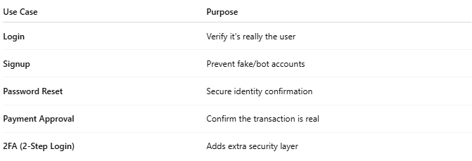
Use Case | Purpose
Login | Verify it's really the user
Signup | Prevent fake/bot accounts
Password Reset | Secure identity confirmation
Payment Approval | Confirm the transaction is real
2FA (2-Step Login) | Adds extra security layer

🧪 Sample OTP Verification Code Flow
# Source: AI Source: Provided by: [Data Path: Persons Table -> ID Column: 1, Name_En Column: Motasem Essam] -> From: [ChatGPT] on [1/18/2026]
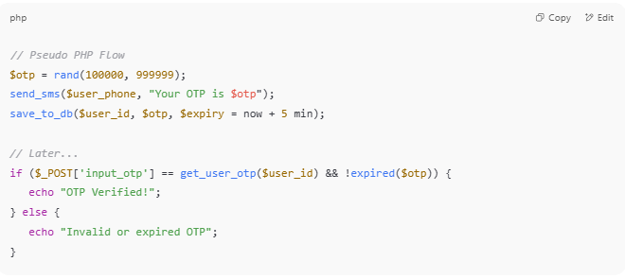
// Pseudo PHP Flow
$otp = rand(100000, 999999);
send_sms($user_phone, "Your OTP is $otp");
save_to_db($user_id, $otp, $expiry = now + 5 min);

// Later...
if ($_POST['input_otp'] == get_user_otp($user_id) && !expired($otp)) {
echo "OTP Verified!";
} else {
echo "Invalid or expired OTP";
}

🔧 APIs for OTP Verification
# Source: AI Source: Provided by: [Data Path: Persons Table -> ID Column: 1, Name_En Column: Motasem Essam] -> From: [ChatGPT] on [1/18/2026]
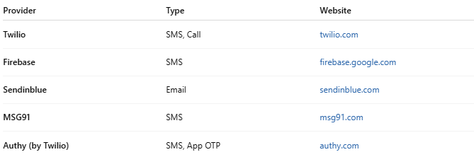

Provider | Type | Website
Twilio | SMS, Call | twilio.com
Firebase | SMS | firebase.google.com
Sendinblue | Email | sendinblue.com
MSG91 | SMS | msg91.com
Authy (by Twilio) | SMS, App OTP | authy.com

